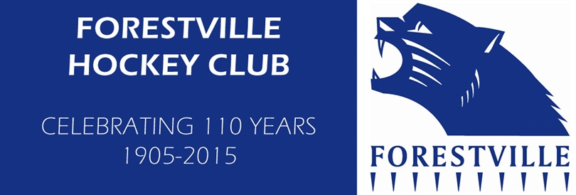

Interested in playing hockey? Forestville Hockey Club, located at the Goodwood Oval complex, Fairfax St, Millswood, is running ‘Hookin2Hockey’ (for 5-10 year olds) and ‘Come and Try’ skill development (7-12 year olds).

Hookin2Hockey is Hockey Australia’s national junior program designed to give boys and girls the opportunity to learn the basic skills of hockey, develop fundamental motor skills and make friends all while beginning their lifelong love of hockey! It is an 8 Week program on Sundays 9-10am, commencing 19th February 2017. Cost $85 includes Participant Pack containing singlet, ball, shin guards, hockey stick and backpack!
Go to www.hookin2hockey.com.au enter your postcode and select the Forestville program to register or express interest.

Come and Try Skill Development are free sessions for boys and girls who want to give playing hockey a try, maybe to follow up on some school sessions or to come with a friend.
Sessions will be running on Sundays 10-11am commencing 19th February 2017 for 4 weeks. Bring your own mouthguard (or buy one on the day $7) and shin pads (some for sale $15). Sticks can be borrowed from the Club.

For further information email juniors@fhc.com.au or contact Julie Mills on 0402 250 511.

